Learning Agreement
International Collaborative Double Degree Program in
Master of Engineering in Chemical Engineering (KU) and
Master of Engineering in Chemical and Material Engineering (THU) (the registered degree from THU)
Between Kasetsart University (KU) and Tunghai University (THU)

Learning agreement made for this Double Degree Program was signed by KU and THU on (date of the Agreement)
Administrative Coordinator (KU)  [Name] …………………………………………………………….  Telephone: ……………………………………………………..  E-mail: …………………………………………………………….. | Administrative Coordinator (THU)  [Name] …………………………………………………………….  Telephone: ……………………………………………………..  E-mail: ……………………………………………………………..

Academic Coordinator (KU)  [Name] …………………………………………………………….  Telephone: ……………………………………………………..  E-mail: …………………………………………………………….. | Academic Coordinator (THU)  [Name] …………………………………………………………….  Telephone: ……………………………………………………..  E-mail: ……………………………………………………………..

Student’s Name: ( Mr/Miss/Mrs/Title ) ………….……………………….………….………………………….…………..
Program type: Dual/Double Degree Program Joint Degree Program
Degree: Doctoral Degree Plan 1.1 Plan 1.2 Plan 2.1 Plan 2.2
Master’s Degree Plan A1 Plan A2 (to be confirmed)
Student’s ID No.: ………………….…..… Major Field: …………..………..….……..…… (Major Field Code: …….…) Subject Group (if any): ………………….……………….….…....… Department: ……………..………………….………..….. Minor Field (if any): ………………………….…………………..…… Campus: ……………….…………....…….…….…...……. Semester/Year of Admission: ……..…..……../……….....…… Contact Phone No.: ……………….………..…….…
E-mail: ………………………………………………………………………………………………………………………………………………….

Degree at the Home Institution: Master of Engineering in Chemical Engineering
Degree at the Host Institution: Master of Chemical Engineering and Materials Science
Tunghai University’s registered degree

Thesis Supervisor (KU)  [Name] …………………………………………………………….  Contact Phone No.: ……………………………………….  E-mail: …………………………………………………………….. | Thesis Supervisor (partner institution)  [Name] …………………………………………………………….  Contact Phone No.: ……………………………………….  E-mail: ……………………………………………………………..

Plan of Participating Period: 1 year 2 years Other …………………….………………
(student will be registered at KU for at least 2 years)
English Proficiency:
Master Program | Doctoral Program
Utilize result from TOEFL, IELTS, CU-TEP,  KU-EPT, KU-TOEFL-ITP | Utilize result from TOEFL, IELTS, CU-TEP,  KU-EPT, KU-TOEFL-ITP
To register for the English Proficiency Course  (Code 01355501 (audit)) | To register for the English Proficiency Course  (Code 01355501 (audit))  Student must obtain S for the paper exam and is required to have the oral exam.
academic transcript from previous international studies | -

Plan for English Examination (if any): …………………………………………………………………………………

Agreed Curriculum: (to be confirmed after discussion)
Seasons | Locations | Course
Semester 1 | KU THU | KU Course code, Course title, Credit
Semester 2 | KU THU | KU Course code, Course title, Credit
Semester 3 | KU THU | THU Course code, Course title, Credit
Semester 4 | KU THU | THU Course code, Course title, Credit
Semester 5 | KU THU
Semester 6 | KU THU

Note: 1. Attach a copy of the curriculum structure of both institutions
2. Attach details of credit transferred subjects between the two institutions (if any)

Arrangements for completing any coursework and/or training requirements or equivalent:
KU’s regulations
Credit transfer is allowed for equivalent or similar courses, and students may be asked to do additional courses subjects to meet the specific program’s requirements. The total credit transfer allowed is 50% by KU. Request for credit transfer must fulfill the following requirements:
i) The course must be approved by each party for credit transfer
ii) The minimum grade obtained is “B”.
THU regulations
............................ [Please add details here, If any. Or leave blank].........................................

Arrangements for completing requirements and equivalent progress reviews.
KU:
i) Appointment of Thesis advisory committee
(submit to The Graduate School within the 4th semester, counted from the beginning of their studies.)
ii) English Proficiency Examination (To be completed in the 1st semester)
iii) Pass Qualifying Examination (QE) / Comprehensive Examination
(iv) Submission of Thesis proposal
Master Degree: within 4 semesters after first semester of registration
(v) Final Oral Examination
(vi) Completion of thesis publication or approval of thesis publication.

† Any KU or THU co-advisor(s) will be counter as an internal examiner. In this case there will need to be four (4) examiners in total and KU will need to find an additional external examiner.

THU:
Possess one of the following English proficiency qualifications:
- TOEIC: a minimum score of 550 (to be confirmed)
- IELTS: a minimum score of 6.0 (to be confirmed)
### KU has a table of “equivalent scores” IELTS/TOEFL/others, would THU be okay with that? Please see below ###

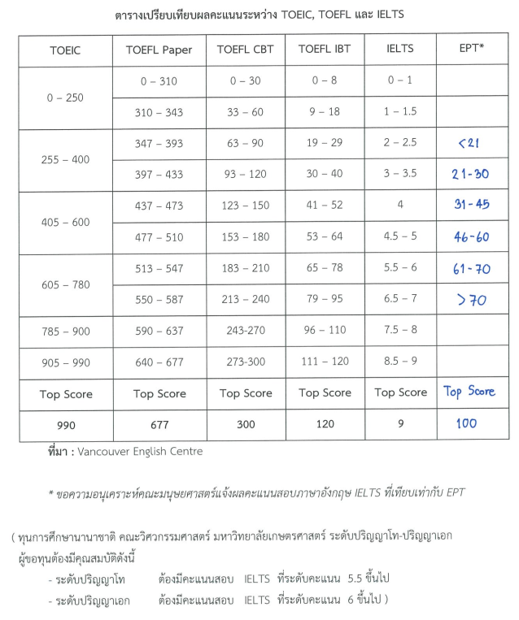

............................ [Please double check details here] .................................................................

Both Institutions have caused this agreement to be executed by their duly authorized representatives in the year 2024.

(Assoc. Prof. Dr. Weeraphart Khunrattanasiri) [Name] ……………………………………………………
Dean, the Graduate School (KU) Dean, the Graduate School...partner institution..
Date…………………………………………. Date………………………………………….

(Professor Dr. Wanchai Yodsudjai) (Professor Dr. xx)
Dean, Faculty of Engineering (KU) Dean, College of Engineering
Date………………………………………………………. Date………………………………………………………..

[Name] …………………………………………………… [Name] ……………………………………………………
Academic Coordinator (KU) Academic Coordinator (partner institution)
Date………………………………………………………. Date………………………………………………………..

[Name] ……………………………………………………… [Name]…………………………………………………………..
Thesis supervisor (KU) Thesis supervisor (partner institution)
Date……………………………………………………………. Date…………………………………………………………….

[Name] ……………………………………………………….
Student
Date……………………………………………………………..

